

electronic Customs management system
User Guide

On

road mANIFEST- aPPROVAL

Version: 1.0
Date: 05/09/2022

About Yang Khor Pvt Ltd

Yang Khor IT Solutions is a leading In-country Technology Solutions Provider providing solution in terms of hardware, software, support, and services as its complete package.
Yang Khor IT Solutions has been serving its purpose since 2005, it now has emerged to be an unprecedented leader as a Solution Integrator with a differentiated vertical approach to providing innovative solutions. Yang Khor uses its solution integration capabilities to integrate best-of-breed products through its key technology alliance partners to provide “End to End” solutions. Provide customized business solutions that help organizations accelerate revenue growth, increase market penetration, optimize operating costs and improve employee productivity, by embedding communication in their business processes.

Yang Khor IT Solutions has achieved to be the Gold Partner of HPE, Service One Partner of HPE, Microsoft Silver Partner and VMWARE Professional Partner and having this Partnership we are able to serve the best of solution to our clients. Yang Khor IT Solution initially focuses on providing the best solution in terms of hardware and software, to serve the purpose of making life better with the Advance Technology which the world is moving forward with.

DOCUMENT HISTORY
S.No | Date | Version. No | Description | Approved By
1 | 05/09/2022 | 1.0 | First Release

Contents
Chapter 1- About This Guide 4
Purpose and Audience 4
Document Conventions 4
Chapter 2- Getting Started 5
End-user experience of the self-service process 5
1. Logging In 5
1.1. Forgot/Reset password? 7
Chapter 3- Approve Exemption. 10
A. DRC Level 1 Exemption Approval 10
B. DRC Level Search Exemption 15
C. DRC Level 2 Exemption Approval 16
20
Chapter 4- Logging Out 20

Chapter 1- About This Guide
Welcome to the Trade Facilitation Baseline Customs Management System (eCMS) user guide for CFA USER! This user guide aims to enumerate the process and steps involved in using eCMS.
This user guide is divided into different topics and sub-topics. Each topic discusses and shows the steps of the modules that the eCMS.

Purpose and Audience
This user guide will help the user to get a quick reference on usage of the system.

Document Conventions
Refer to this section to familiarise yourself with the visual aids used throughout the user guide.
Navigation
To assist you with accessing screens, pages, or windows, refer to the following navigation format:
Click User Registration>>Users
Buttons, fields, and other system elements
All system elements are highlighted in Bold text.
Hyperlinks
All topics mentioned in the user guide’s content are hyperlinked. Click on the hyperlink to view the referenced topic.
Callouts
Callouts are presented differently from the original CONTENTS and highlight certain information.
There are two types of callouts: tips and warnings.

@ | A Tip provides useful information that helps you complete a task or procedure.

! | A Warning refers to information that may be critical to the system’s functionality and might affect data or system stability.

Chapter 2- Getting Started
Refer to this chapter to familiarize yourself with the eCMS System; how to log in, Approve Exemption, and log off from the system.

End-user experience of the self-service process

Logging In
To log in to the eCMS:
- Type in URL http://uat.ecms.gov.bt/ECMS/login/indexBhutan.jsp in your Internet browser to access the eCMS System.
- eCMS Front End landing page will display as below,

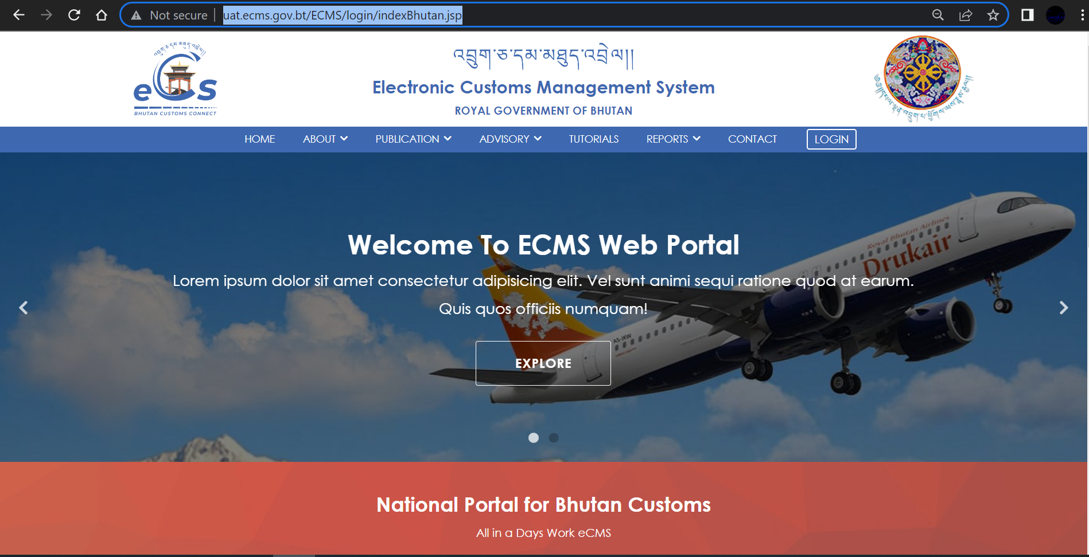

Fig.1. eCMS Landing page

- Click>>> LOGIN available on the top right corner of the landing page

  - Click >>LOGIN, the following login screen (Figure 2) is displayed

eCMS Login

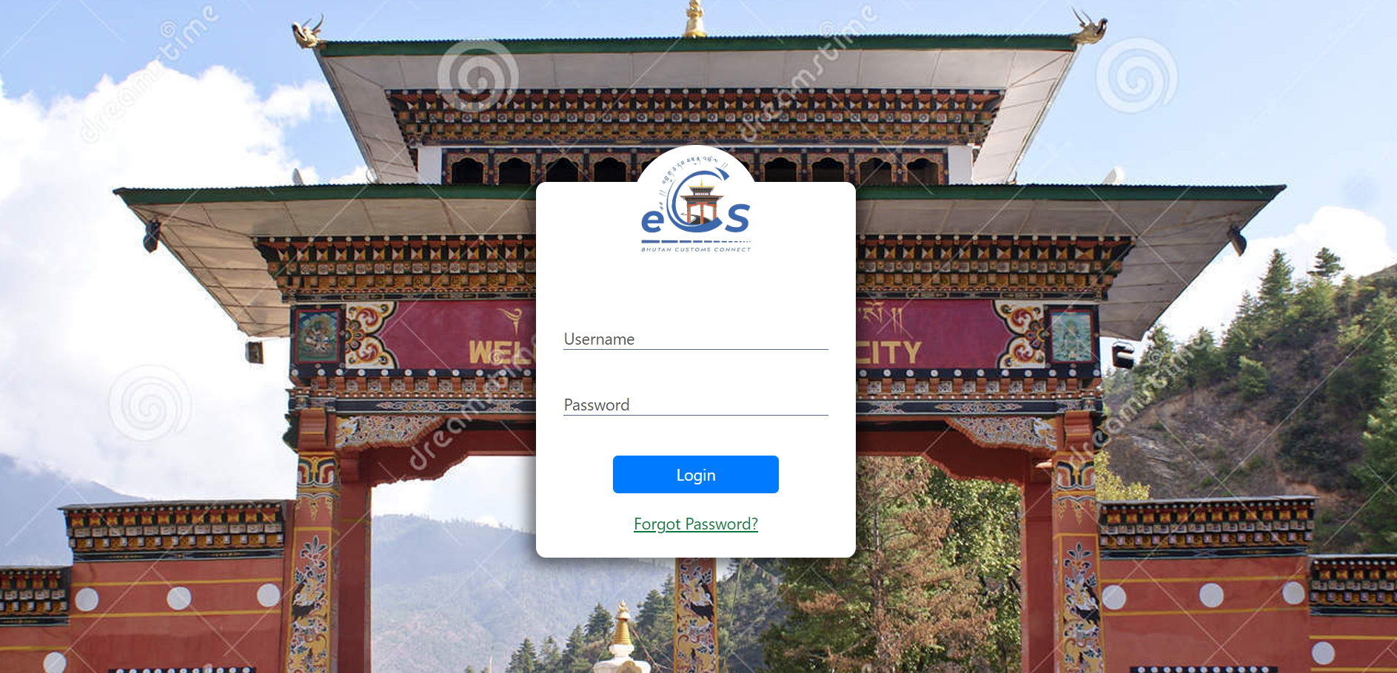
fig.2. eCMS login Page

  - Enter the USERNAME and the PASSWORD in the fields provided and Click button.

@ | In case you need to reset or forgot your password, On the login page, the user clicks the Forgot Password? link to start the process. The new password will be sent to your registered email.

Forgot/Reset password?
- If User Password is expired or forgot , Click >>“Forgot Password?”, “Forgot password Form” is displayed as shown in the figure 3 above.

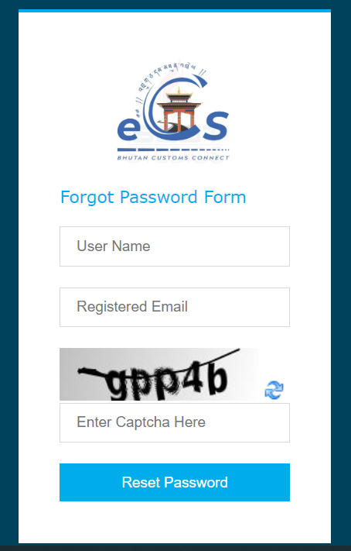
Fig.2. Forgot Password Form.
- Fill in the required details “User Name”, “Registered Email”, “Enter Captcha” and click on “Reset Password” Buttom. The subsequent screen is displayed;
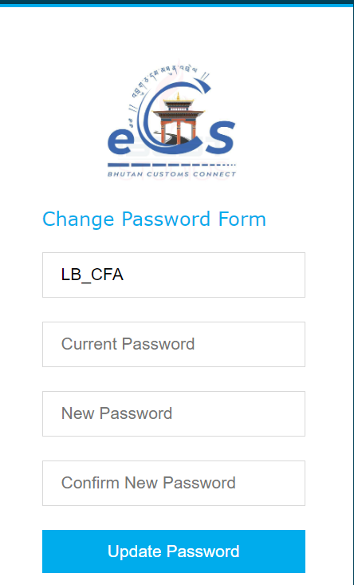
Fig.3. Update password

- Check your email for the password provided by the system and input in “Current Password” Field.
- Set your New Password and Confirm New Password.

- Click >> Update Password, the initial login page is displayed as below;

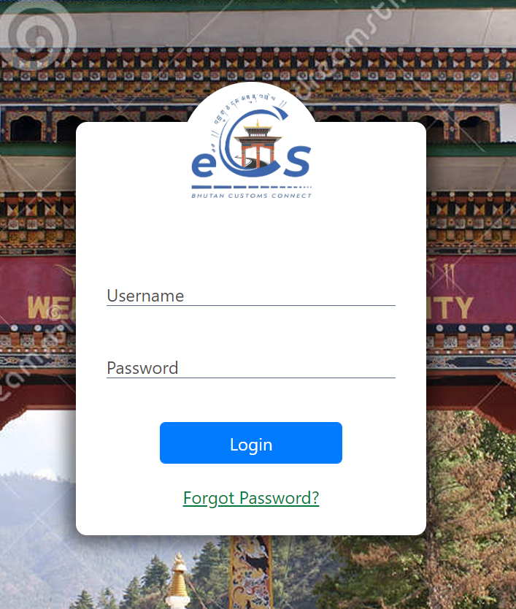
Fig.4. eCMS Login Page
- Enter the USERNAME and the NEW PASSWORD in the fields provided and Click “LOGIN” button.

Click>> LOGIN

- Upon successful login the Electronic Customs Management System Home Page will be displayed as shown below.
Dashboard Page

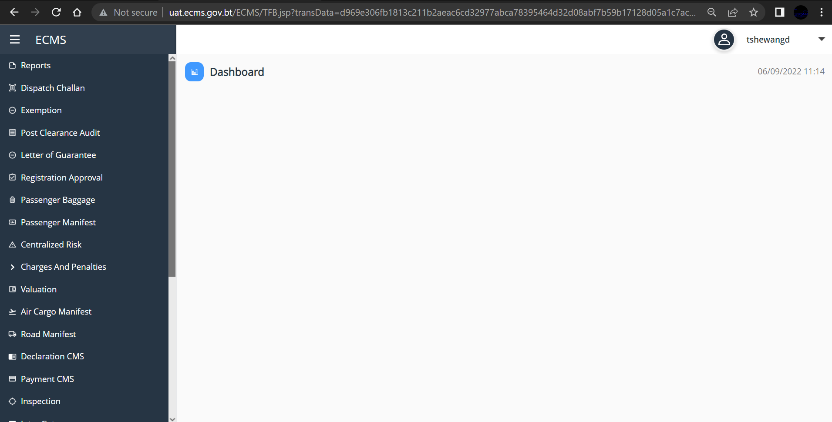
Fig.5. eCMS Dashboard (CFA)

Chapter 3- Approve Air Cargo Manifest.

Approval Air Cargo Manifest
- Go to Air Cargo Manifest menu and click on “Approve Air Cargo Manifest”. Subsequent Screen is displayed with the list of Manifest Applications in the dashboard.
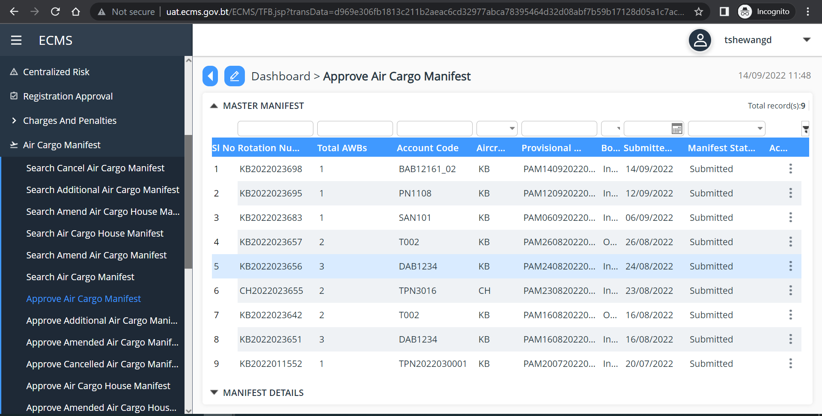
Fig.6. Approve Air Cargo Manifest Dashboard

@ | - Passenger Manifest applications are listed based on number of applications submitted  - You can track/search the Passenger Manifest Application with Manifest number/No. of Passenger/Aircraft Code/Flight no./Bond Type/Port of initial Arrival/Submitted date/ Created by/Status
- Click on the manifest application to view their details. You can also view by clicking on the “View” button available in the three dots in the right of the manifest. The details can be view as below;

- Manifest Header
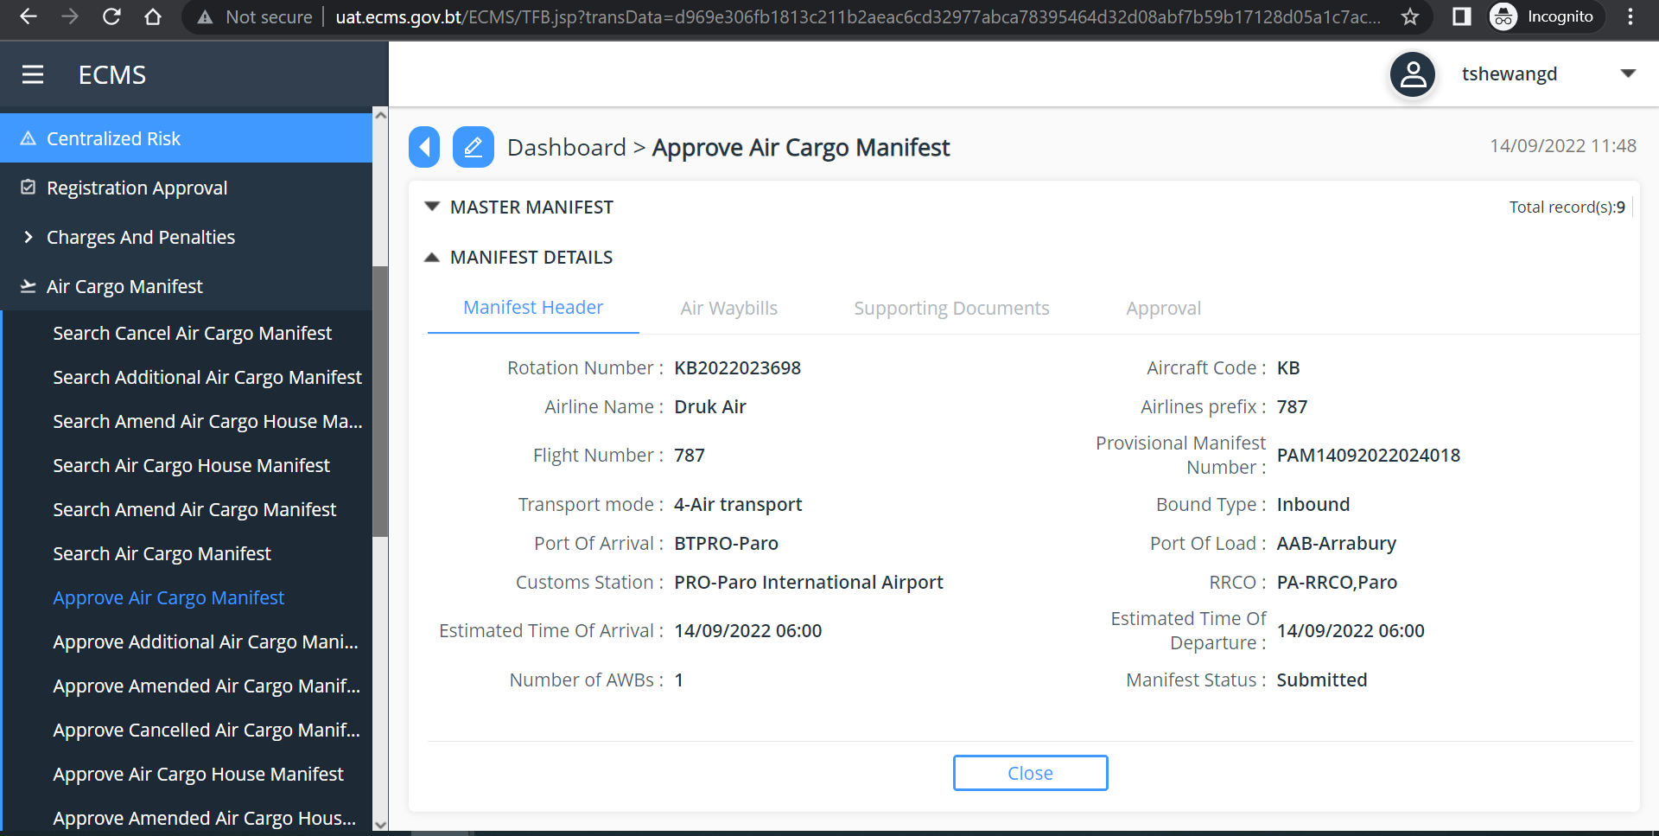
Fig.7. Air Cargo Manifest Header Details
- Click>> Air Waybills
- Click on the to view the details OR click on the three dots available at the right end of Air waybill list to view the details.
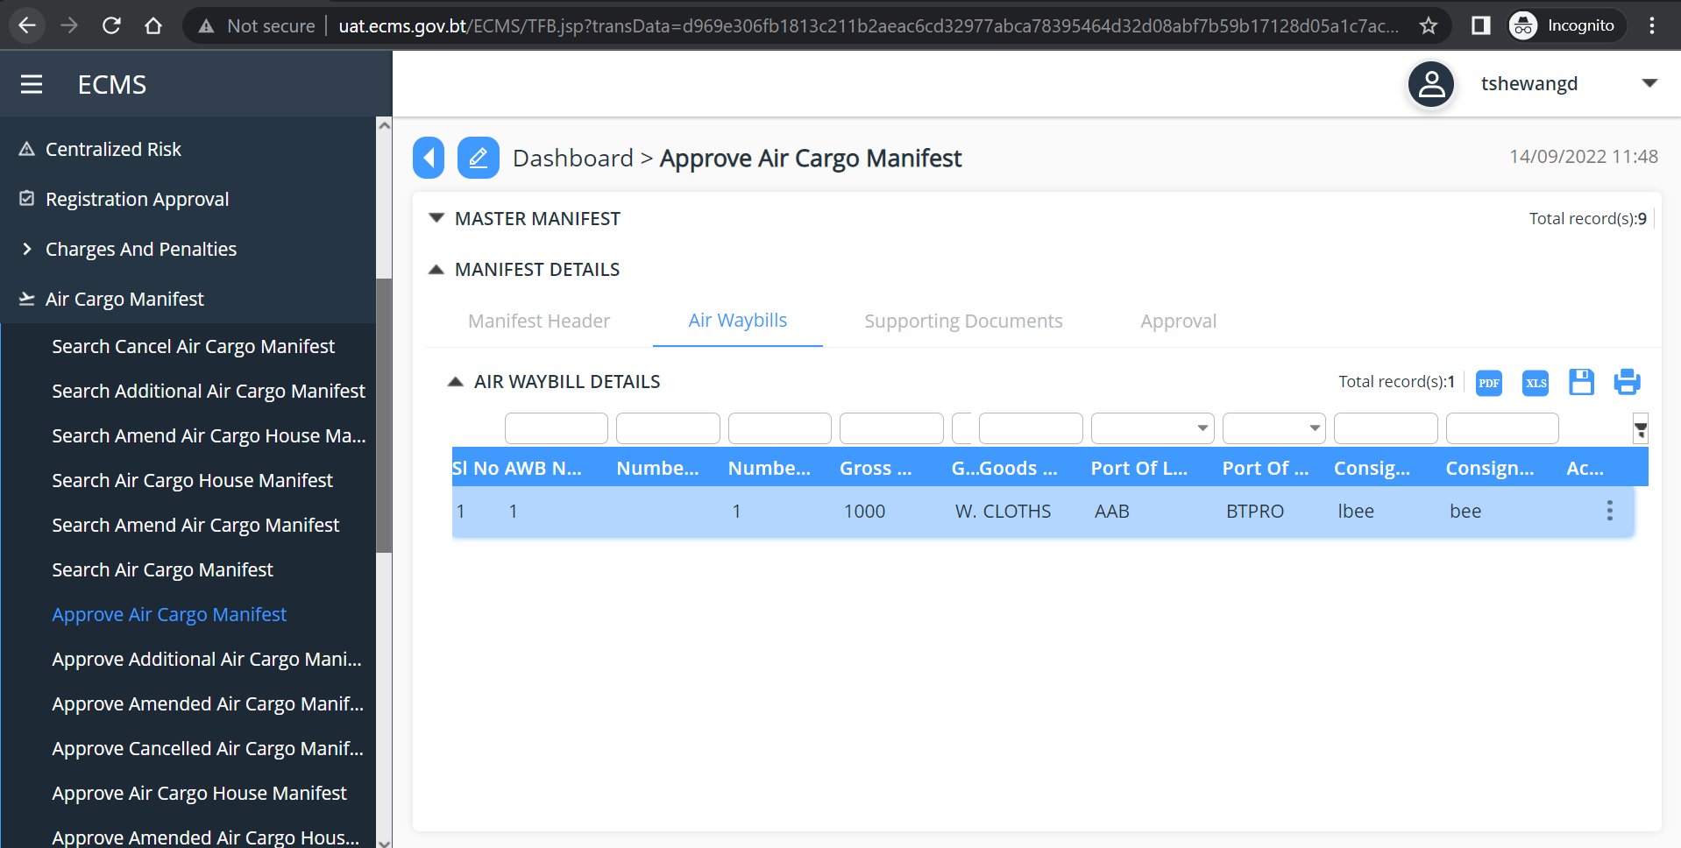
Fig.8. View Air waybills details

- Click Supporting Document
- Click on the Invoice to view the details OR click on the three dots available at the right end of Air waybill list to view the details.

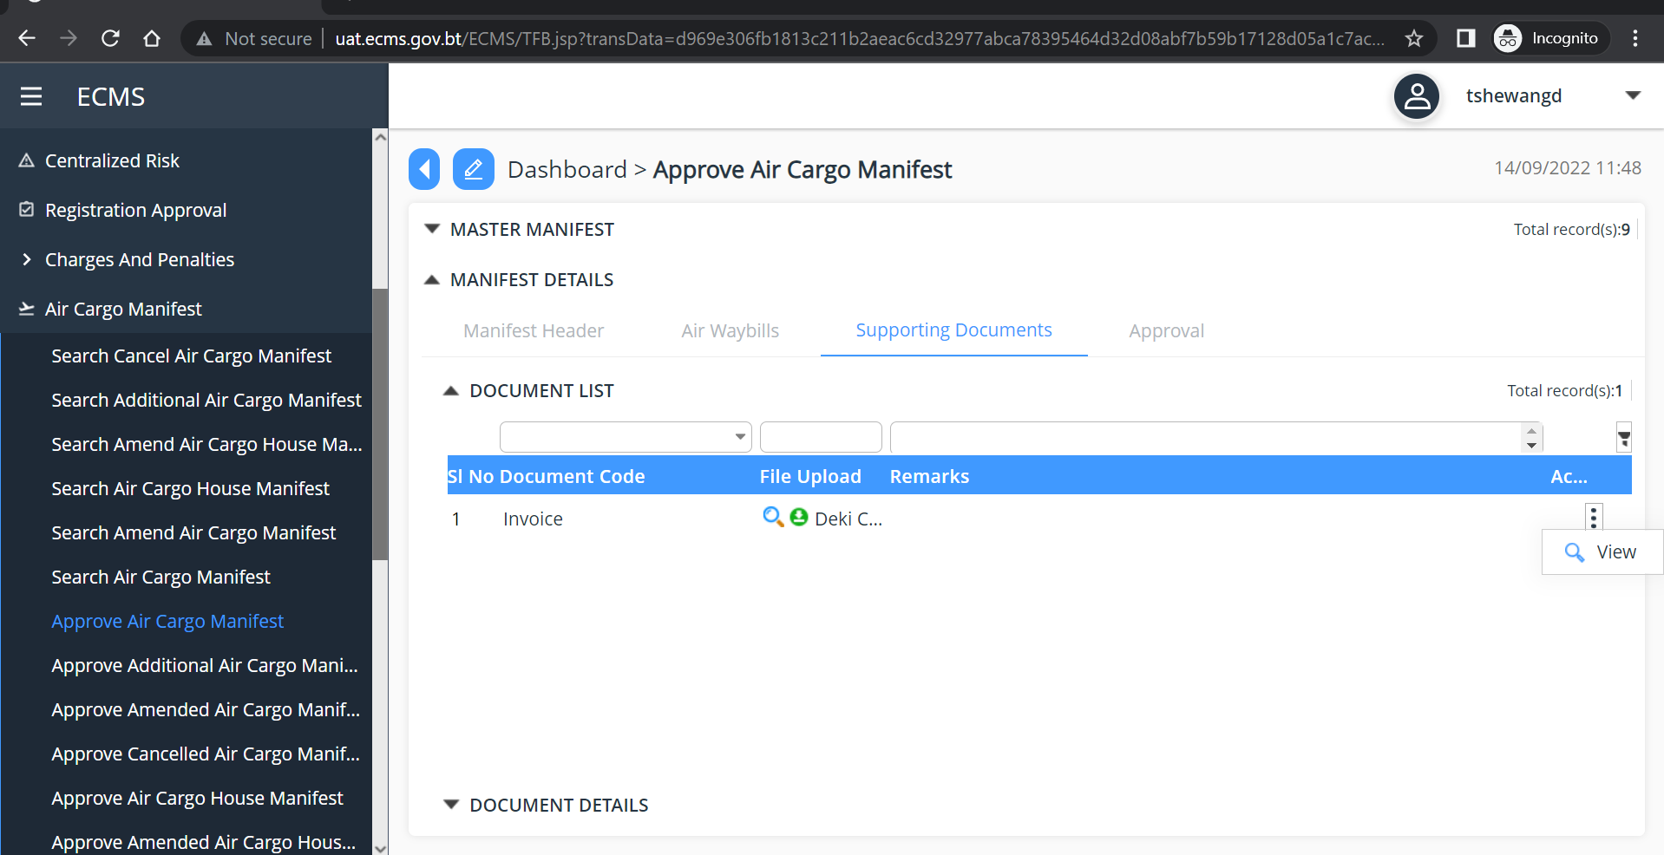

- Click>> Approval
Table item in Dropdown list consist of;
Field name | Drop down list | Description
*Status | Approved | Mandatory
 | Rejected
 | Rejected for Amendement
Remarks |  | Non-Mandatory
- From the dropdown list in the “Status” select your decision as “Approved”/” Rejected”/”Rejected for Amendment”.
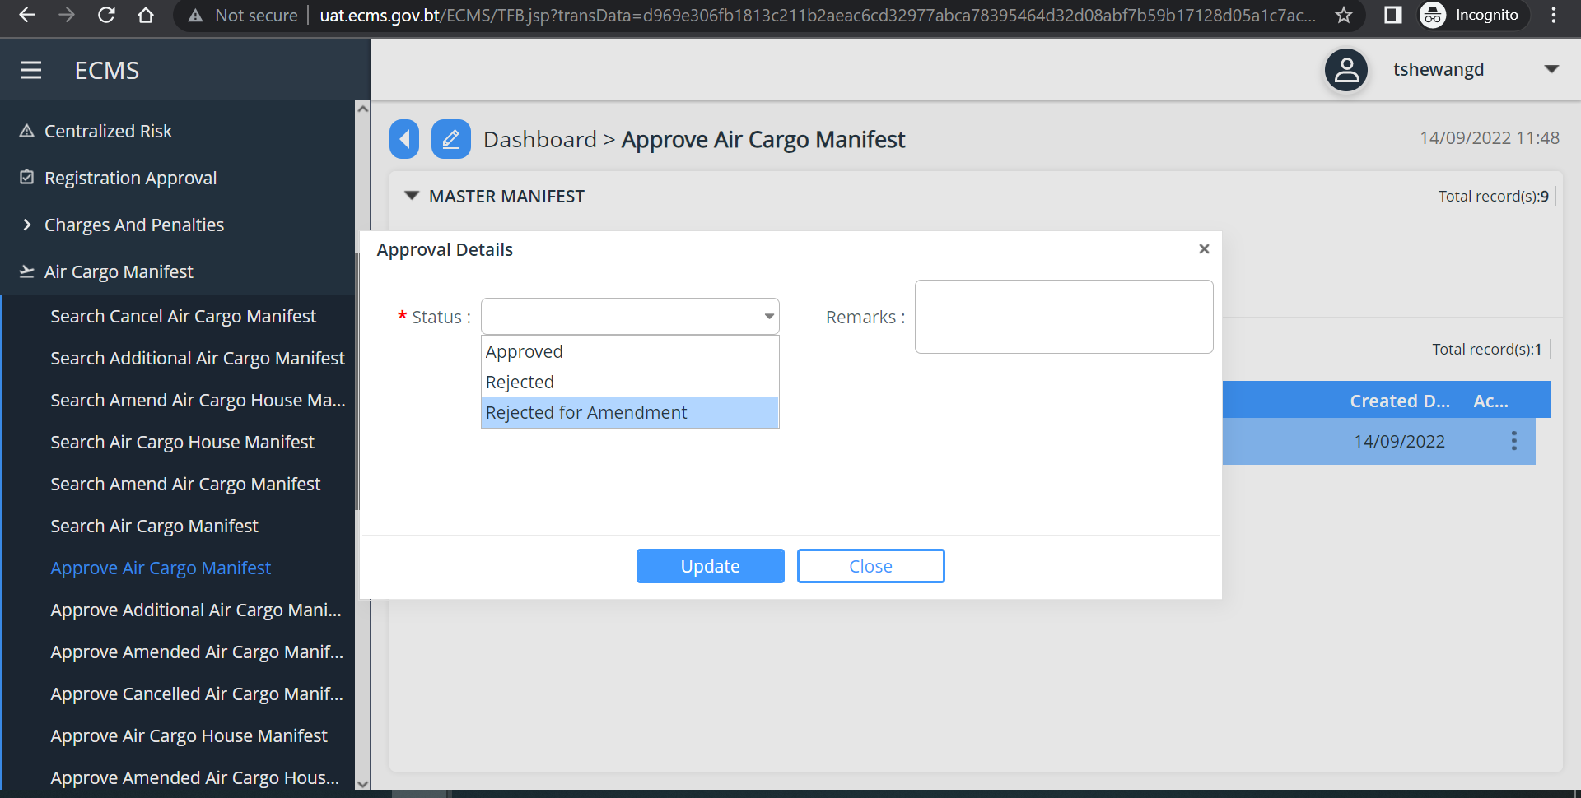
Fig.9. Approve passenger Manifest

- Click >> “Update”

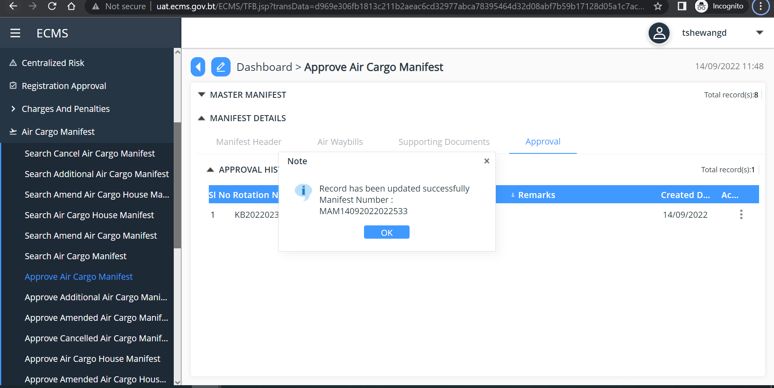
Fig. 10. Air Cargo manifest Update Success

Search Passenger Manifest
- Go to Passenger manifest menu and click on “Search Passenger Manifest”. Below given screen is shown.
- to search specific Passenger Manifest, Enter/type in the passenger manifest number in the Road Manifest Field and press enter
- Passenger manifest will be displayed. Click on the manifest to view the details Submitted.
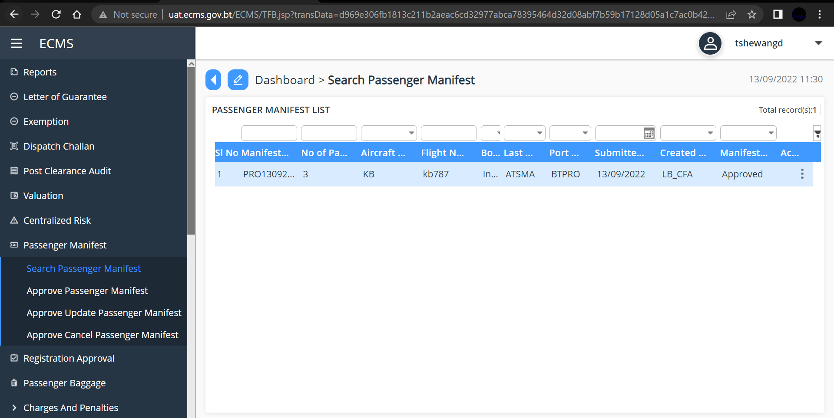
@ | - Manifest applications are listed based on number of applications submitted  - You can track/search the Passenger Manifest Application with Manifest number/No. of Passenger/Aircraft Code/Flight no./Bond Type/Port of initial Arrival/Submitted date/ Created by/Status
Fig. 11. Search Passenger Manifest Dashboard

Approve Update Passenger Manifest
- To approve Update Passenger Manifest, go to Passenger Manifest in the menu and Click “Approve Update Passenger Manifest”
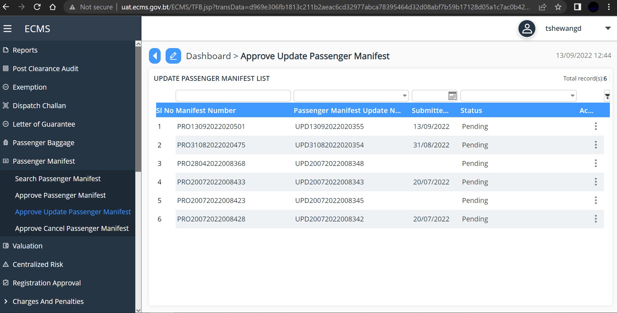

- Click on the manifest you want to Approve, view manifest detail, and Approve.
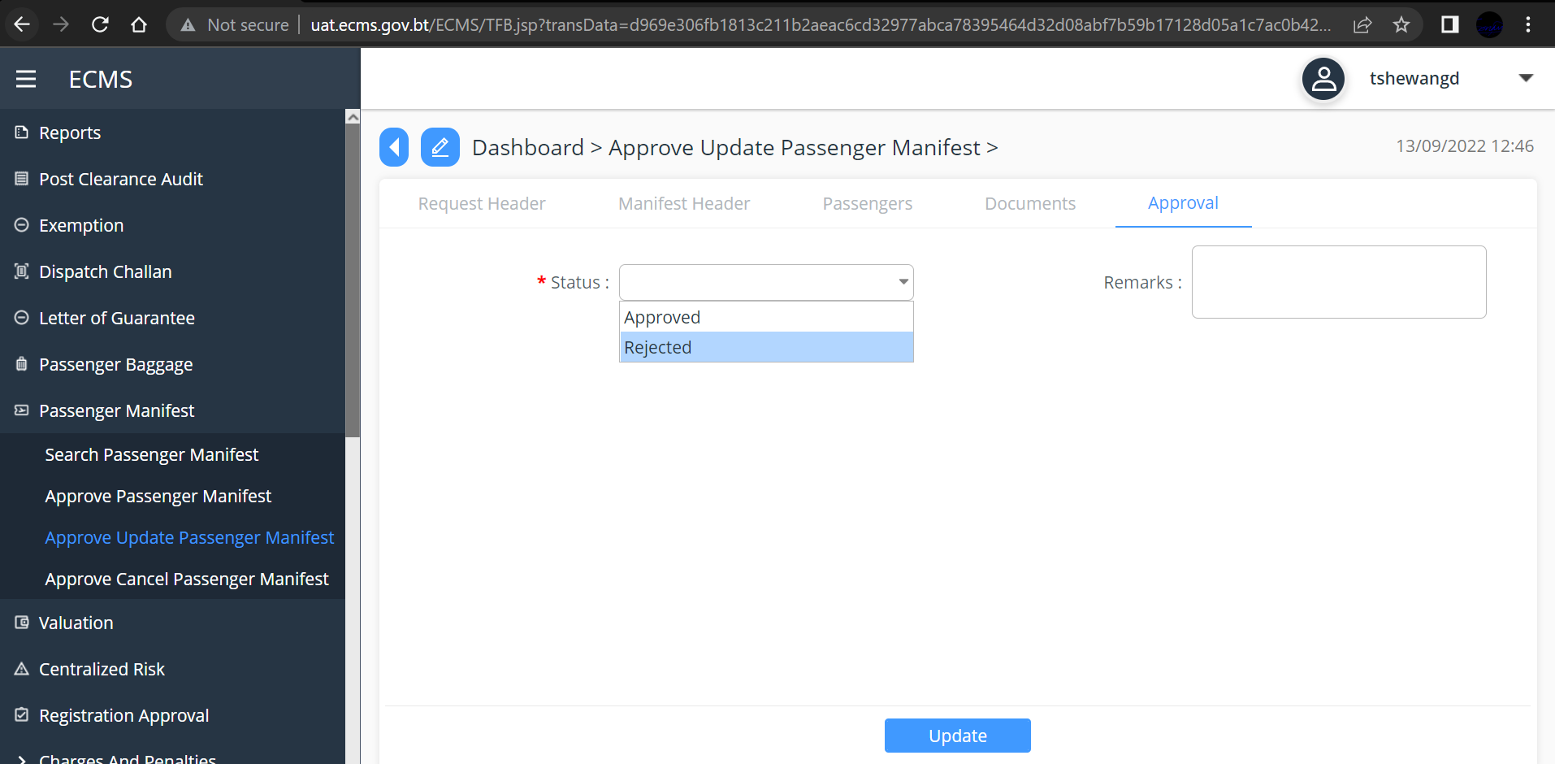

- Click Update

Approve Cancel Request
To Approve Cancel Request
- Go to “Passenger Manifest on Menu and Click on “Approve Cancel Passenger Manifest”. The Subsequent Screen with the list of cancellation request is Shown as below.

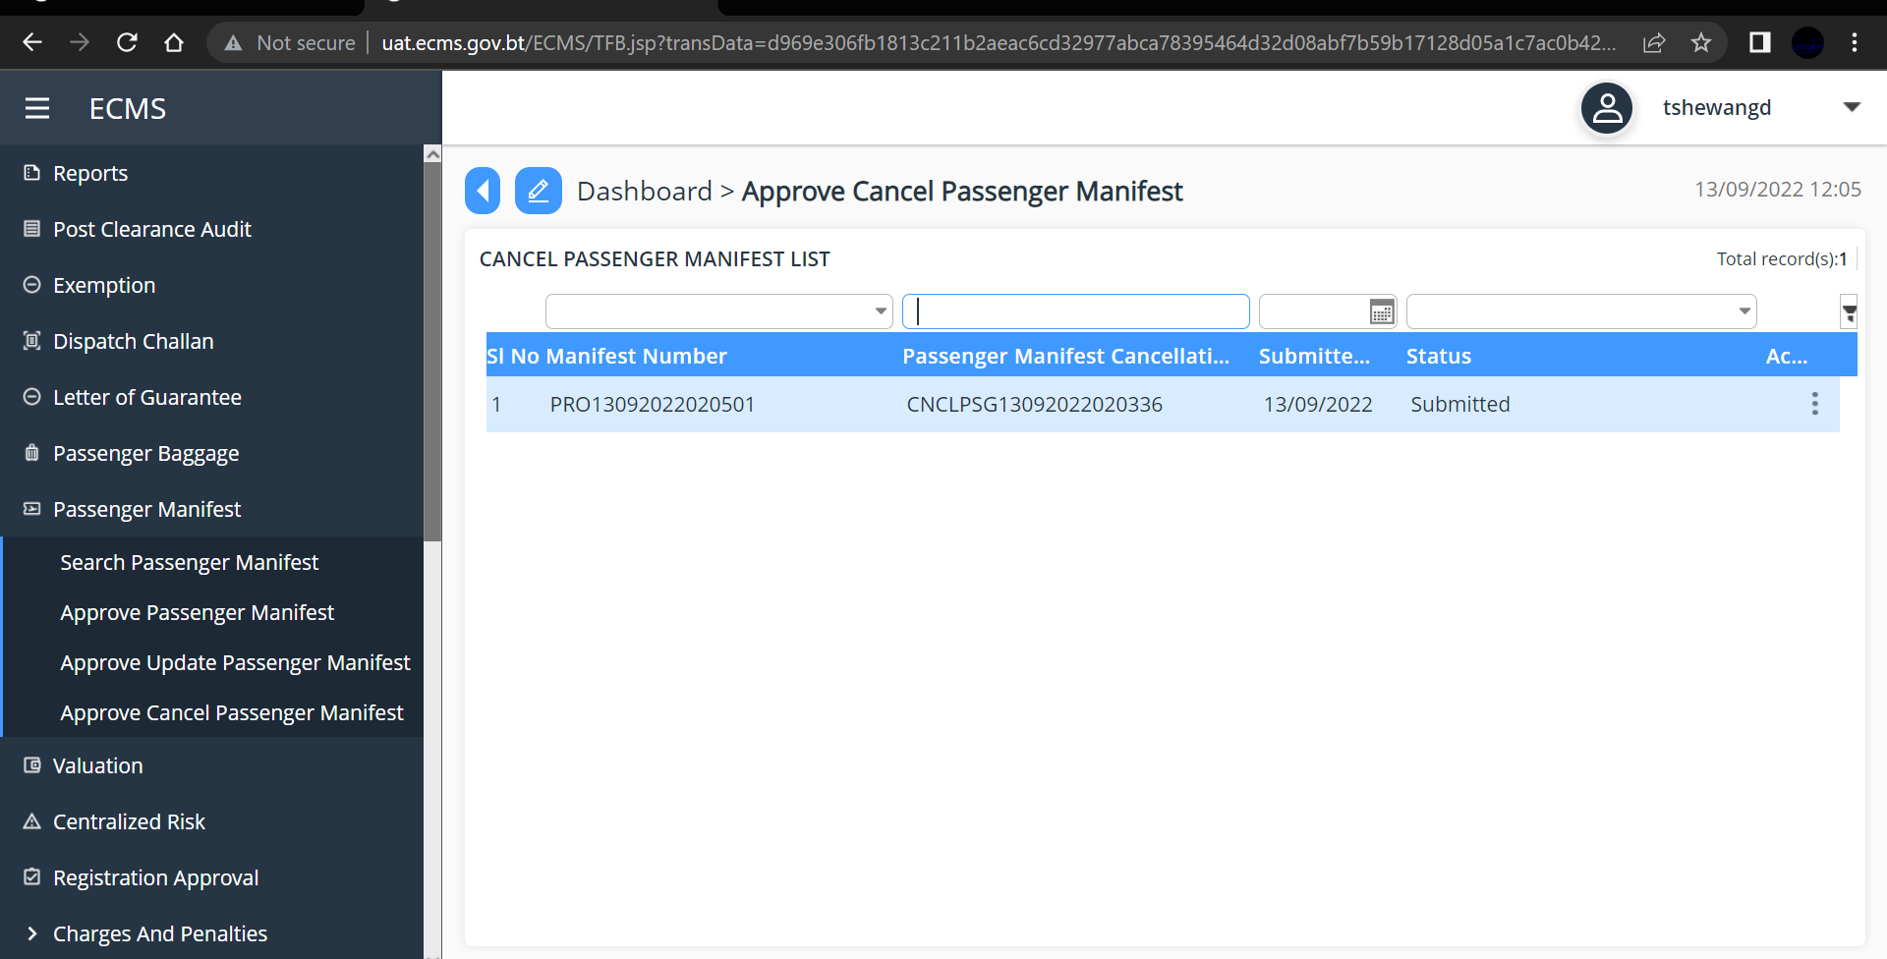
Fig.12. Approve Cancel request Dashboard

- Click on the Application OR cleck on the three dots on the extreme right of the application and click “Edit” below screen is Displayed.
- Select the decision from the drop-down list from “*Status” field
- Click “Approve” button, the system will display “Road manifest cancellation request approved successfully” message.
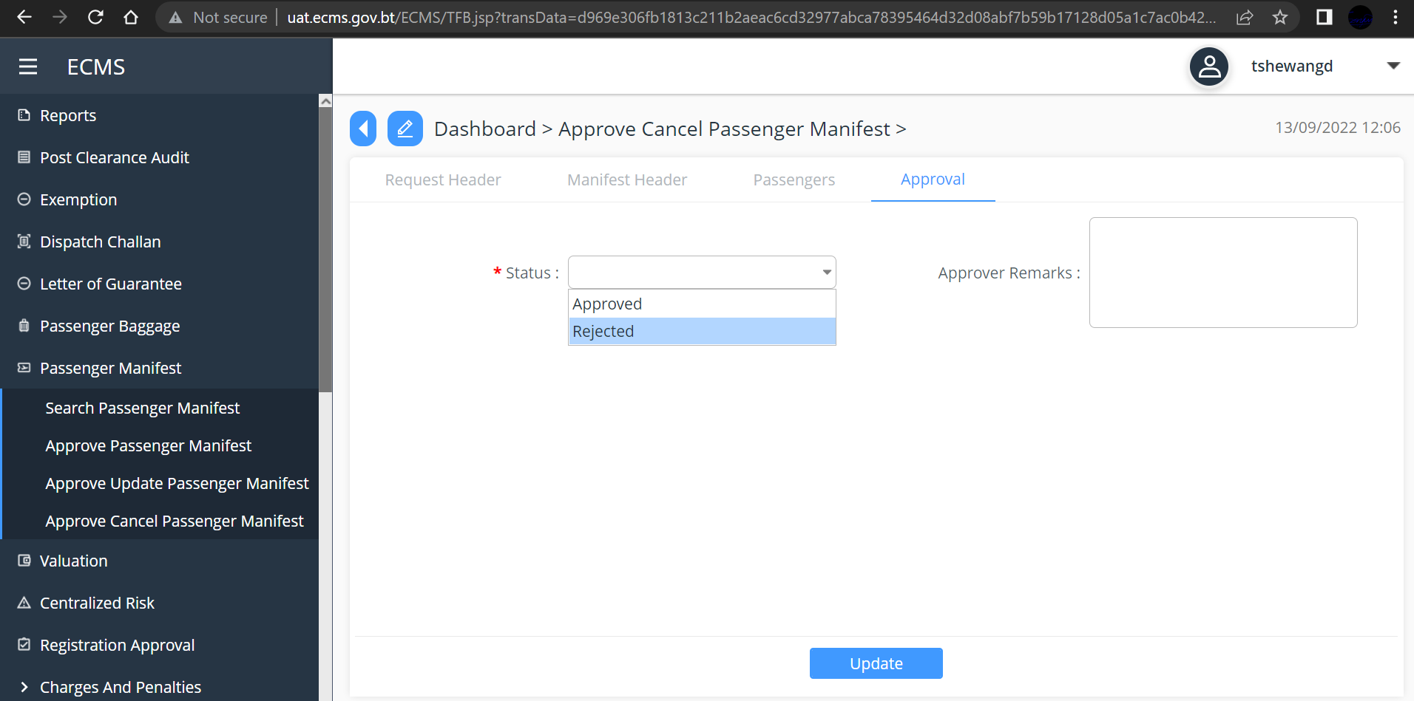

Fig.13. Approve Cancel Request

